HTML, CSS, JS, NODEJS, MONGODB,EXPRESS

Landlord and Tenant –initial modules

|  |  |
| --- | --- |
| LANDLORD FRONT | TENANT FRONT |
| |  | | --- | | Generate Bills-at same time for all users/tenant | | Received payments | | Pending payments | | Show transactions | | Account balance | | Delete user/tenant | | Review authentication | | Set rent metrics | | Create user/tenant- no authentication required | | Property Details | | Expenditure/Profit Analytics** | | Tenant interaction** | |  | |  | |  | | |  | | --- | | Rent notification | | Pay rent | | Transactions | | Delete/remove landlord | | Get transaction details | | Send maintenance requests** | |  | |  | |  | |  | |  | |  | |

**later

--Registration by user itself require authentication by landlord.

Login as 1. USER/Tenant 2. Landlord

DATABASES

|  |  |  |
| --- | --- | --- |
| TENANT | Transaction | LANDLORD |
| enant id  First name  Last name  Mobile no  Email  Room no  Verified  Landlord id  Createdon  ------------------------------  /**  * Paste one or more documents here  */  {  "tenantID": {  "$numberLong": "2"  },  "fname": "Tarun",  "lname": "Rana",  "mobile": "8138432312",  "email": "www.avinashkumar2@gmail.com",  "room": {  "$numberInt": "2"  },  "verified": true,  "landlordID": {  "$numberLong": "3"  },  "idcreatedON": {  "$date": {  "$numberLong": "1589817600000"  }  },  "allotON": {  "$timestamp": {  "t": 1590469929,  "i": 1  }  }  } | Transaction id  DateGenerated  PaidOn  Amount  LandlordId  Tenantid | Landlord id  First name  Last name  Mobile no  baseRent  water  electricity  security  maintenance  createdon  ------------------------------------  "_id" : ObjectId("5ecca5a1a662d920cc2e70e5"),  "landlordID" : NumberLong(1),  "fname" : "Tarun",  "lname" : "Rana",  "mobile" : "8068432312",  "baseRent" : 4500,  "water" : 200,  "electricity" : 500,  "security" : 2000,  "maintenance" : 1200,  "createdON" : ISODate("2016-05-18T16:00:00Z"),  "address" : "#220, Behlaan,Chandigarh",  "startRoom" : 1,  "endRoom" : 100 |

**Using GitHub

<https://github.com/avinash0786/rentingSystem.git>

::::DATABASES::::

Mongo db query

Pending payments: db.transaction.find( { "paidON":null}).pretty()

Received payments:: db.transaction.find( { "paidON": { $ne: null} }).pretty()

User approval :: db.tenant.find( { "verified":false }).pretty()

Rent metrices:: db.landlord.find( { "landlordID":1 }, { "baserent":1, "water":1,"electricity":1, "security":1,"maintenance" :1,"_id":0 } ).pretty()

|  |
| --- |
| **Data in front LANDING PAGE** |
| |  |  | | --- | --- | | **LANNDLORD PAGE **using landlord ID** | **TENANT PAGE ** using tenant and landlord’s ID** | | Name |  | | Unique ID |  | | Month |  | | Received payments, Count ** tenant ID, Name, Amount |  | | Pending payments, Count ** tenant ID, Name, Amount |  | | Total profit |  | | User approval and count |  | | total tenant count |  | | Account balance |  | | New user form last 3 months |  | | Landlord’s rent metrics |  | |

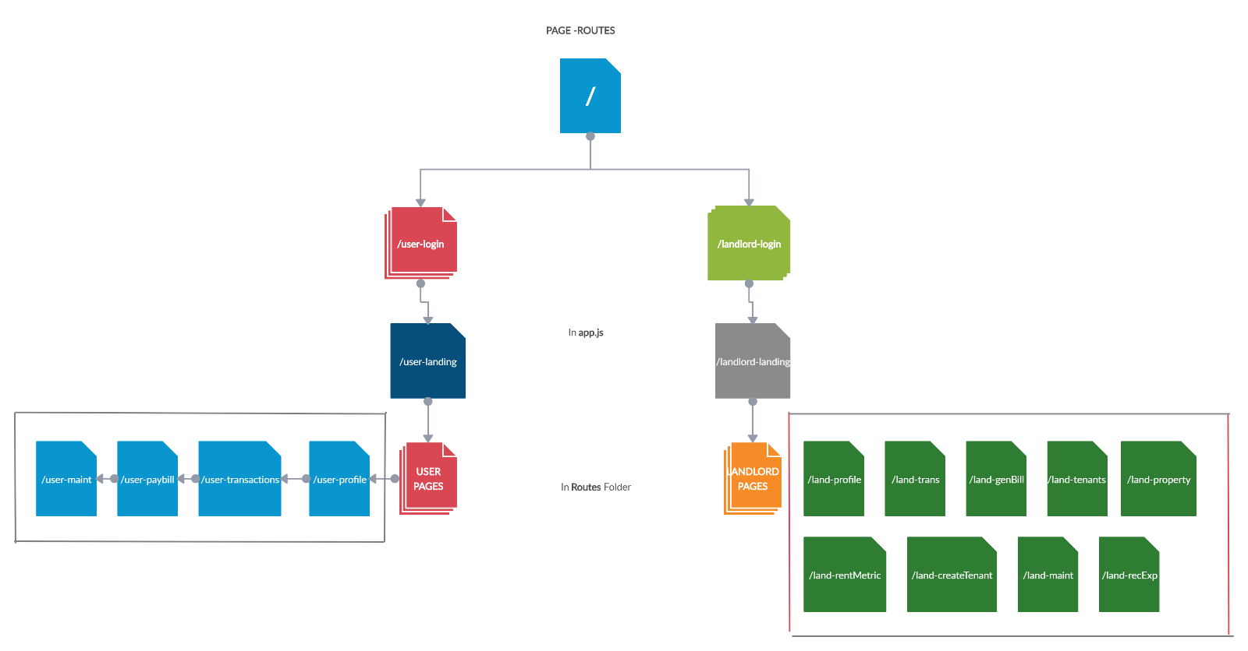

ROUTES:

|  |
| --- |
| / |
| |  |  | | --- | --- | | /user-login /user-signup | /landlord-login /landlord-signup | | |  | | --- | | /user-landing | | /user- profile | | /user- trans | | /user- payBill | | /user-login | | /user- maint | |  | |  | | |  | | --- | | /landlord-landing | | /landlord-profile | | /landlord-trans | | /landlord-genBill | | /landlord-tenant | | /landlord-property | | /landlord-createTenant | | /landlord-rentMe | | /landlord-maint | | /landlord-recExp | |  | |  | | |

ROUTES FLOW:

|  |
| --- |
| /landlord-login |
| ** If user already is signed-in : redirect to landing page  **Else verify and login to landing |

|  |
| --- |
| /landing-login |
| ** If user already is signed-in : redirect to landing page  **Else verify and login to landing |

|  |
| --- |
| /user-login |
| ** If user already is signed-in : redirect to landing page  **Else verify and login to landing |

|  |
| --- |
| /user-login |
| ** If user already is signed-in : redirect to landing page  **Else verify and login to landing |